

|  |
| --- |
| User Guide  **Scheduling OnDemand** |
|  |
| Authors: Robert Martinez, Andrew Ritchie, John Leavitt, Shana Yaswen, Joseph Prince, Kala Christmas  CMSE495-6381 Trends Projects Comp Science  University of Maryland University College  Professor: David Castillo |
|  |





Table of Contents

Scheduling OnDemand 3

Description 3

Objective/Purpose 3

Minimum Requirements 4

Requirements 4

Employee Operation 4

Logging In To Scheduling OnDemand 4

Resetting A Forgotten Password 5

Main Dashboard Navigation 7

Update User Account Information 8

Selecting Available Shifts 10

Canceling Assigned Shifts 11

Management Operation 12

Logging In To Scheduling OnDemand 12

Resetting A Forgotten Password 12

Manager Main Dashboard 15

Managing Users 16

Create A User 16

Modify A User 18

Delete A User 20

Managing Shifts 22

Create Available Shift 22

Modify Available Shift 22

Delete Available Shift 22

Managing User Shift Requests 22

Approve A Shift Request 22

Deny A Shift Request 23

Troubleshooting 23

Scheduling OnDemand Support 23

Email Customer Support: 23

Contact Customer Support: 23

FAQs 23

References 25

# Scheduling OnDemand

## Description

Scheduling OnDemand is a scheduling web application that allows users to view and self-assign to shifts that are currently available to be covered. Management can create, modify, and delete shifts as business demand increases or decreases to maximize business profit by ensuring all fillable schedules are covered.

Scheduling OnDemand is unique in that it’s an efficient and low overhead solution to publishing schedules that are available to be covered. With some employees only working on an as needed basis it can be very costly to purchase and provide business services like Office 365 in order to create a shared schedule. Scheduling OnDemand instead provides a low-cost solution by allowing management to create users that can access specific schedules and see what shifts are available and can be covered.

## Objective/Purpose

* Allow employees to see the most up to date available schedules.
* Allow managers to create, modify, and delete schedules based off business demand.
* Create a web application that is cost efficient and maximizes business profit by streamlining the process for employees to select and cover available schedules.
* Allow managers to manage users within the web application instead of purchasing costly business service like Office 365 for employees what work on a as needed basis.
* Allow employees to modify their personal information as it changes like addresses, phone numbers, and email addresses.
* Allow employees to see what schedules have been assigned to them in order for them to easily keep track and see any updates to their assigned schedules.

# Minimum Requirements

## Requirements

* Operating Systems:
  + Windows 7+
  + Mac OS X
  + Ubuntu, Redhat, or another commonly used Linux distribution
* Internet Browsers:
  + Chrome
  + Firefox
  + Internet Explorer 10+
  + Microsoft Edge
  + Opera
  + Safari

**Note**: At this time, mobile devices are not officially supported and may provide limited functionality.

# Employee Operation

## Logging In To Scheduling OnDemand

1. Open the front page of the application
2. Enter the user’s username and password in the dedicated fields
3. Click on the Login button

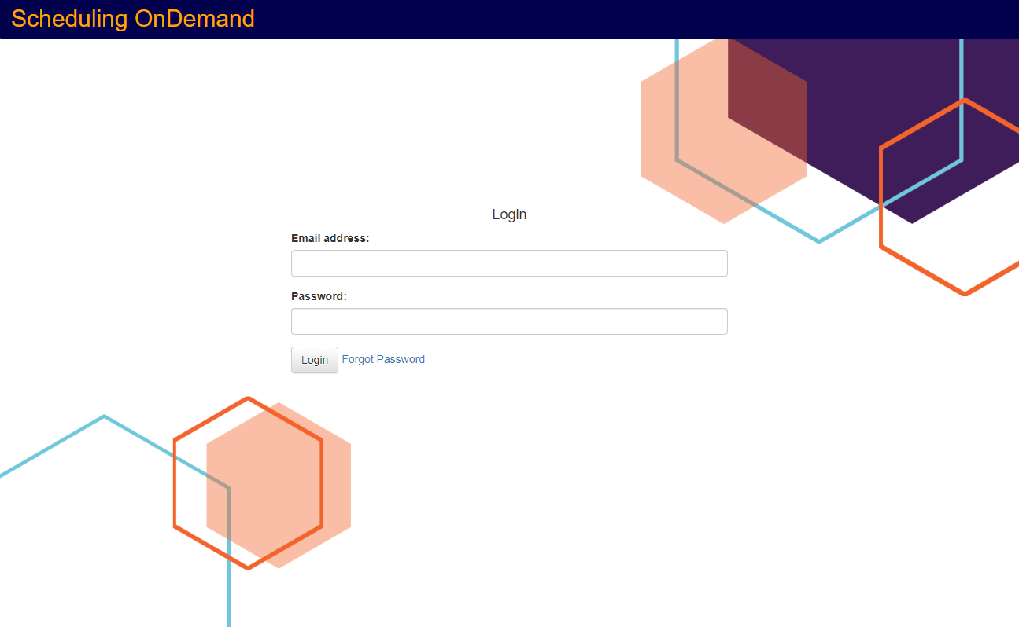

**Step 3**

**Step 2**

### Resetting A Forgotten Password

1. Open the front page of the application
2. Click on the Forgot Password link



**Step 2**

1. Enter your username and click next

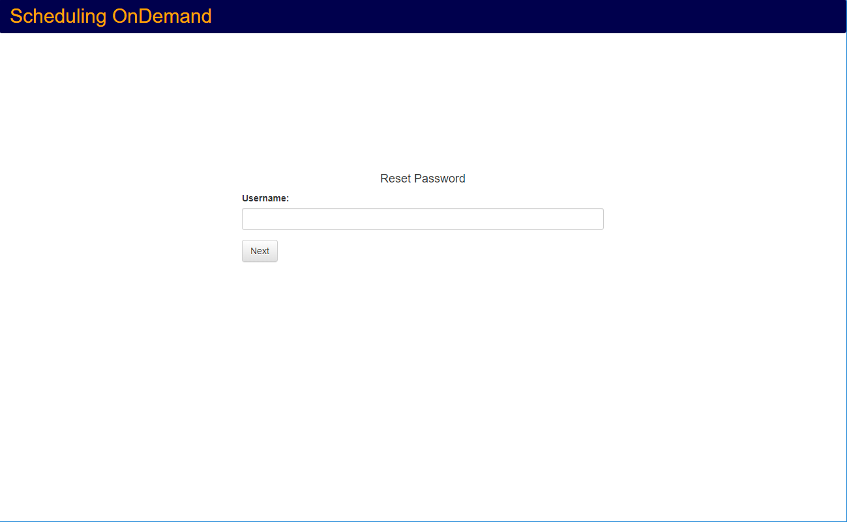

**Step 3**

1. Answer the account security question and click next

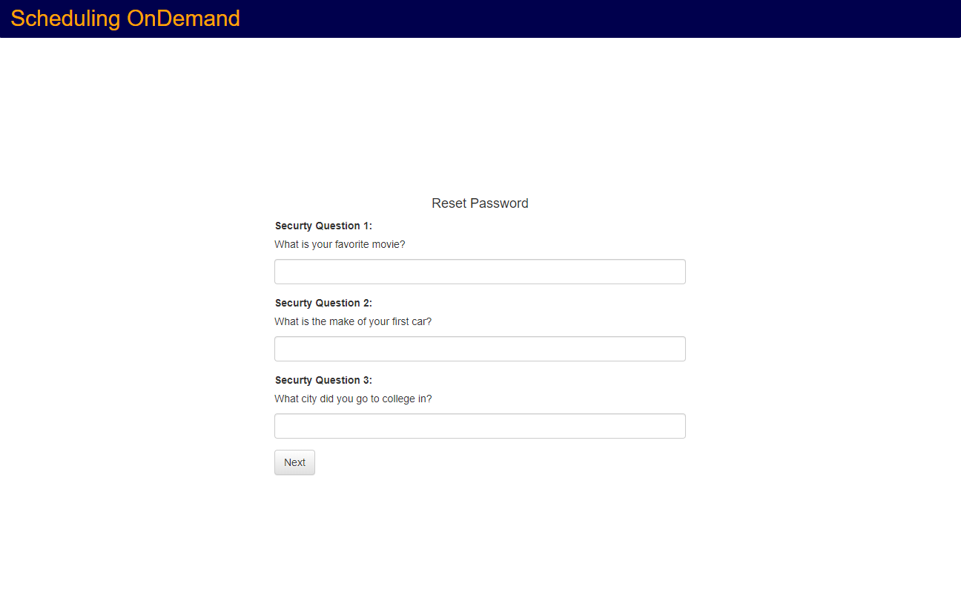

**Step 4**

1. Create a new password and click on next

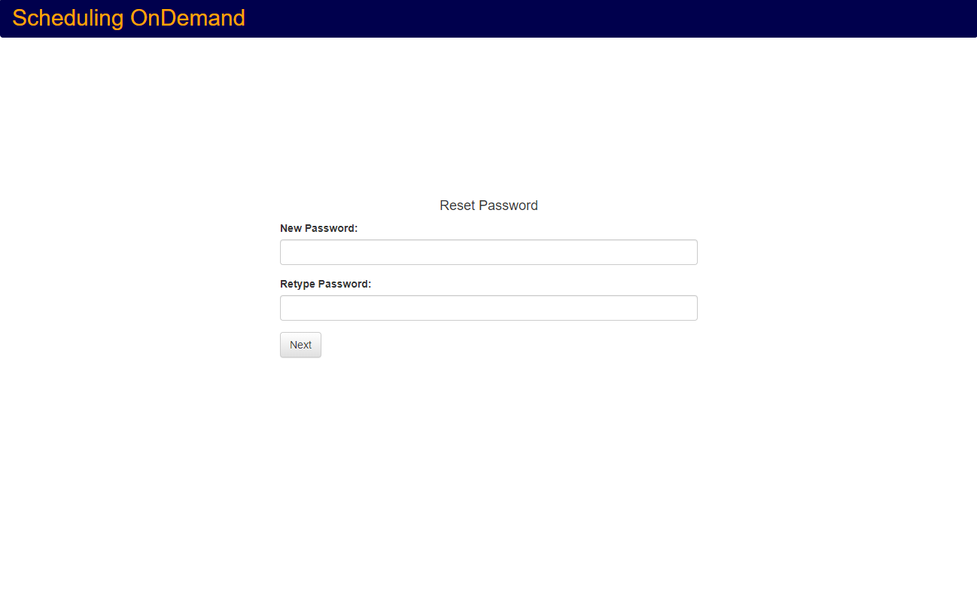

**Step 5**

1. Click on Login and attempt to login using the newly created password

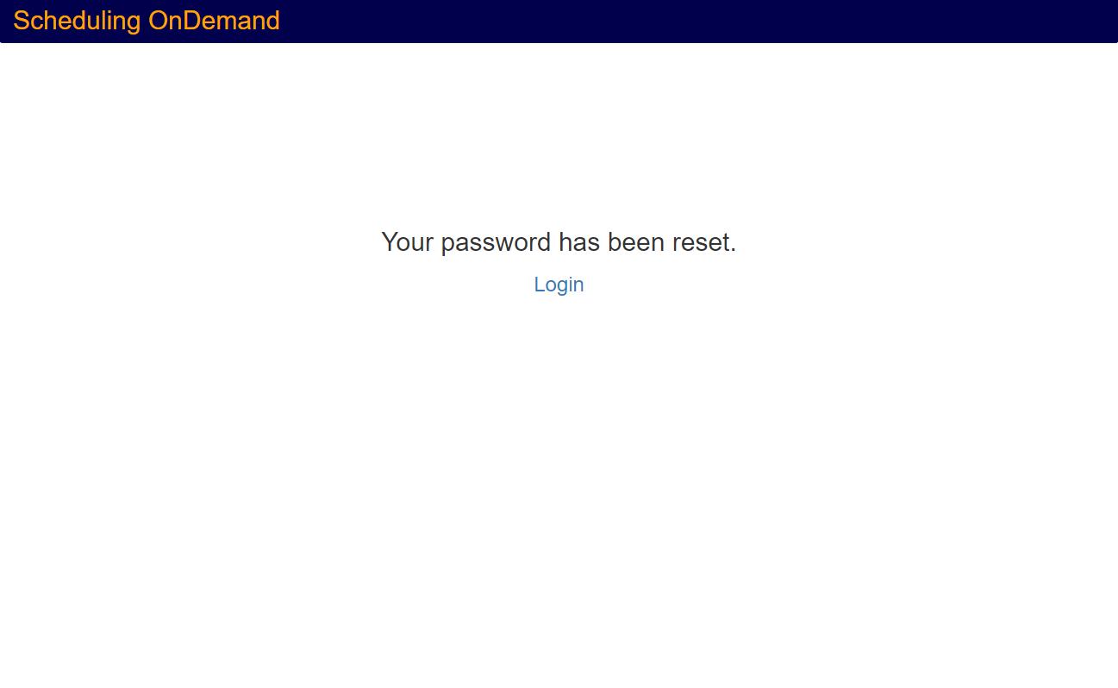

**Step 6**

## Main Dashboard Navigation

1. Navigation Bar Buttons:
   1. Dashboard
   2. Available Shifts
   3. Assigned Shifts
   4. About
   5. Profile
   6. Log Out
2. Refresh Button
3. Main Lists
   1. Assigned Shifts
   2. Pending Approval List
   3. Pending Cancelation List
4. Shift Detail Links

*\*Diagram on next page\**

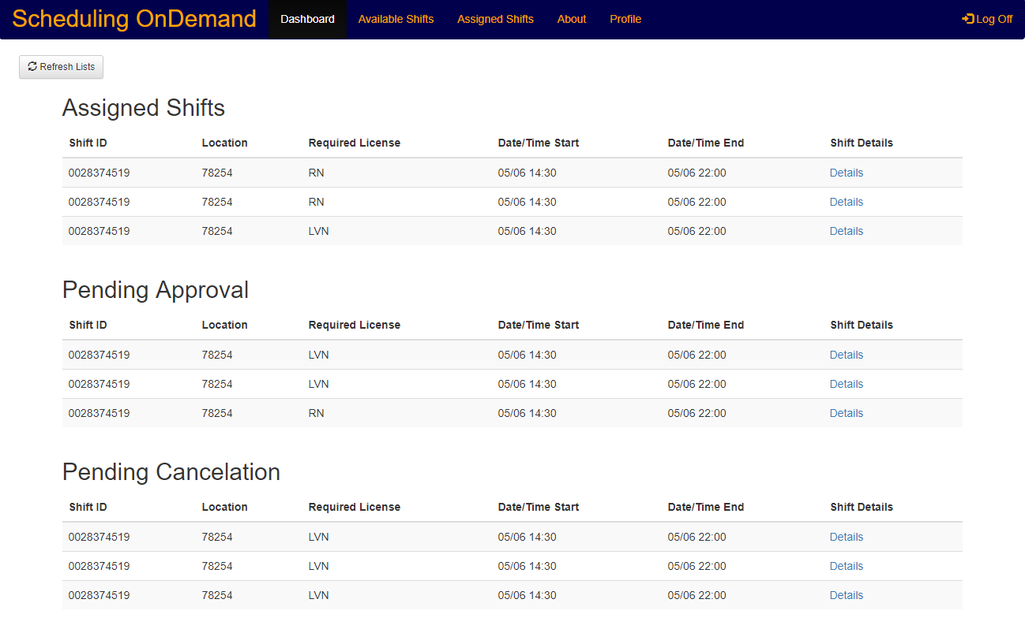

**4**

**2**

**3.c**

**3.b**

**3.a**

**f**

**e**

**d**

**c**

**b**

**a**

## Update User Account Information

1. From the Employee Dashboard click on Profile in the navigation bar



**Step 1**

1. On the profile page click on Edit Profile to edit information related to your profile

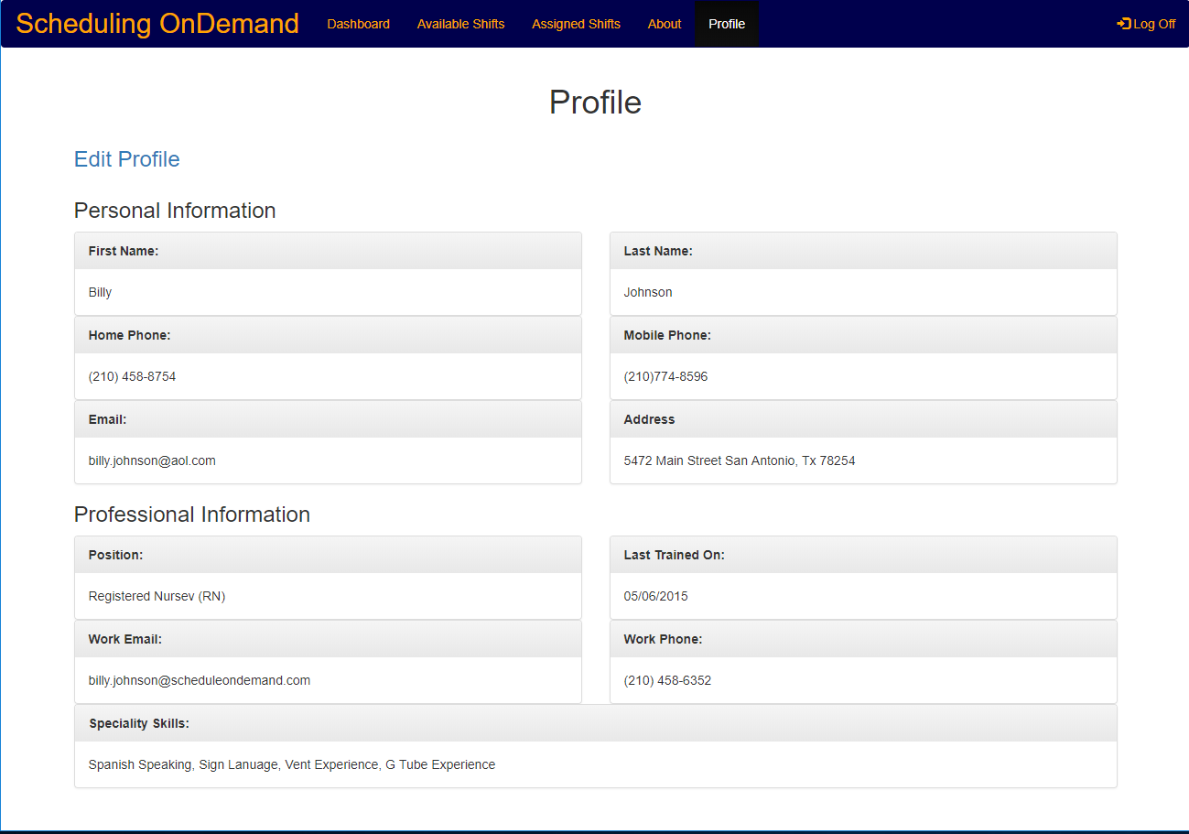

**Step 2**

1. Once on the Edit Profile page update the desired information
2. Click on Save Changes to commit changes to the profile

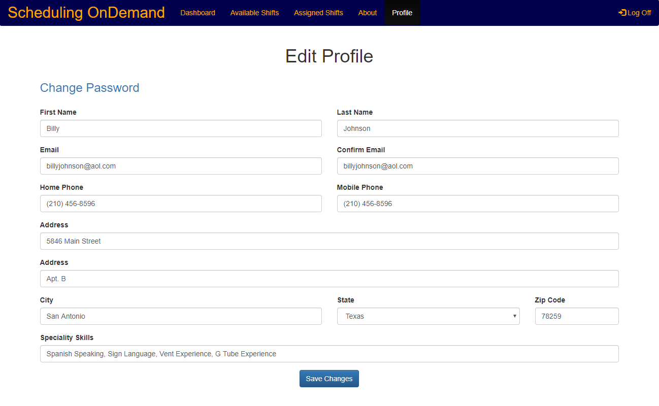

**Step 4**

**Step 3**

## Selecting Available Shifts

1. From main Employee dashboard click on the Available Shifts button
2. Once on the Available Shifts page check the box next the shift/shifts you wish to request

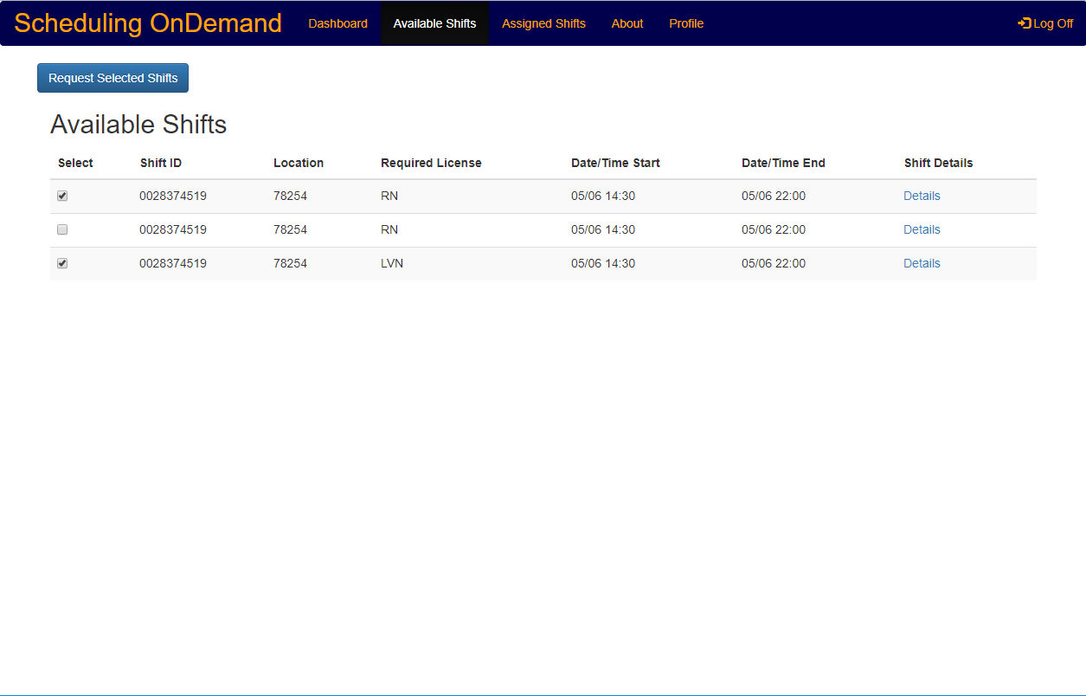

**Step 1**

**Step 3**

**Step 2**

1. Confirm the selections by clicking the Request Selected Shifts button as shown above
2. Once you receive the confirmation you can return to the available shift using the link

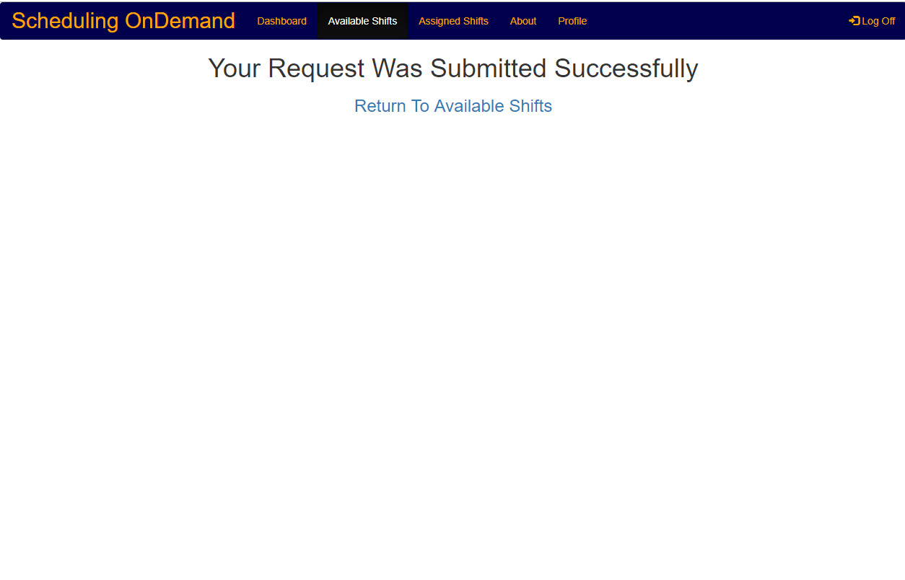

**Step 4**

## Canceling Assigned Shifts

1. From the main Employee dashboard click on the Manage Assigned Shifts button
2. Once on the Manage Assigned Shifts page check the box next to the shift you wish to cancel

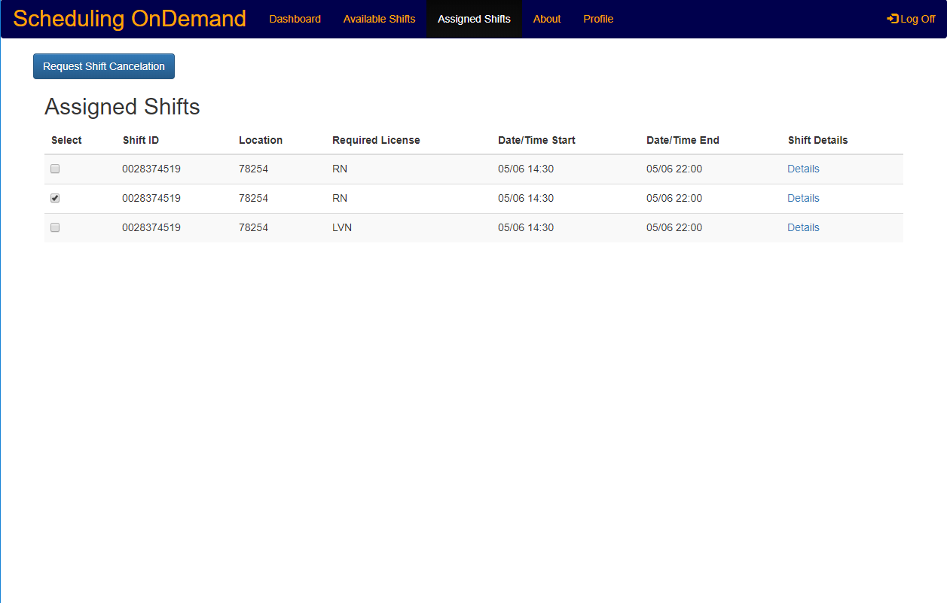

**Step 1**

**Step 3**

**Step 2**

1. Click the Request Cancelation button to request cancelation of the selected shifts
2. Once you are at the cancelation confirmation page you can use the link to return to your assigned shifts

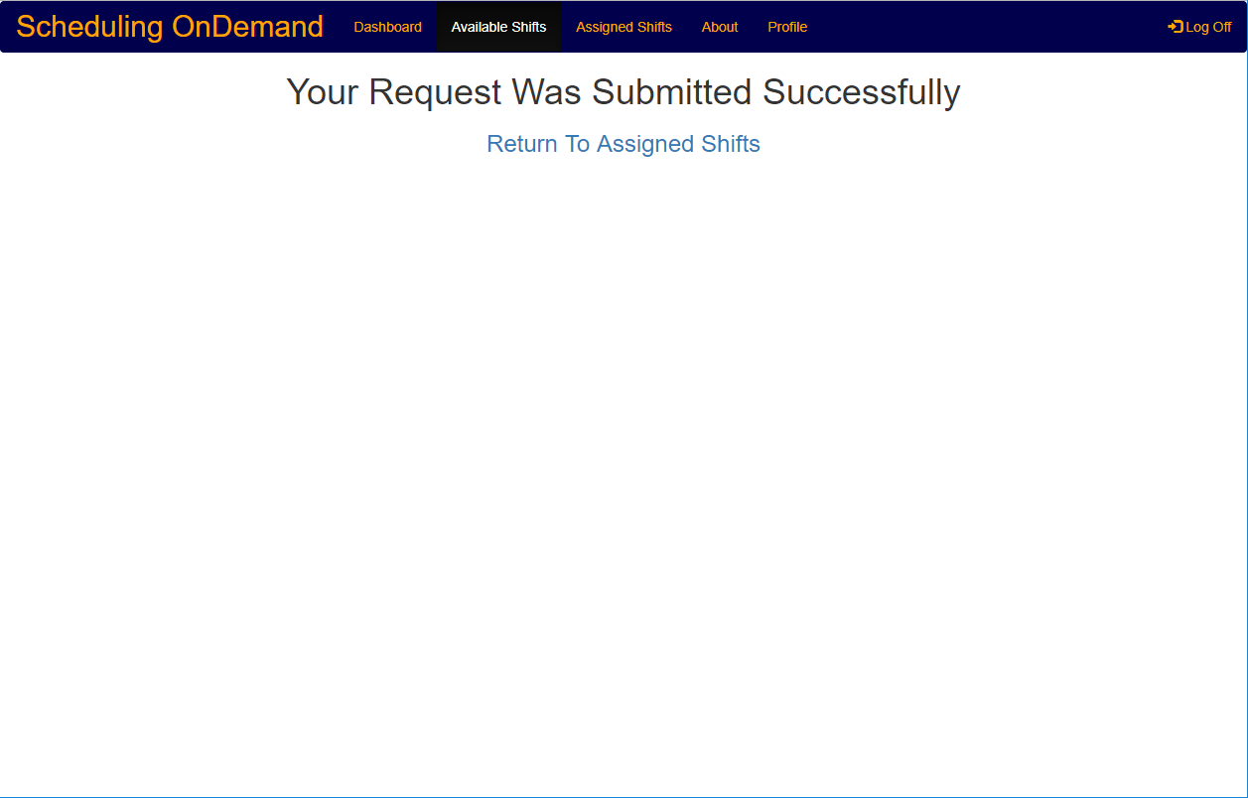

**Step 4**

# Management Operation

## Logging In To Scheduling OnDemand

1. Open the front page of the application
2. Enter the user’s username and password in the dedicated fields
3. Click on the Log In button

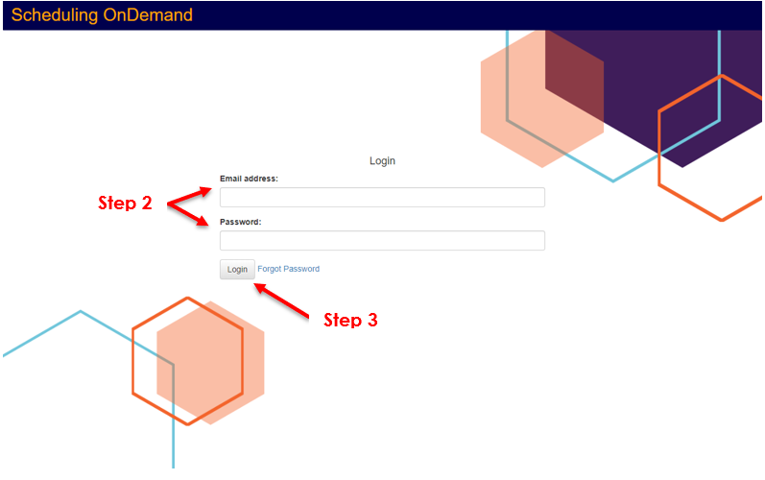

### Resetting A Forgotten Password

1. Open the front page of the application
2. Click on the forgot password link

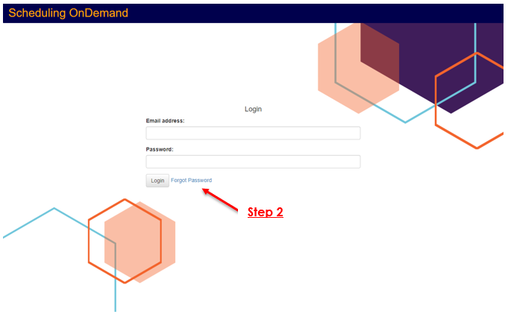

1. Enter your username and click continue

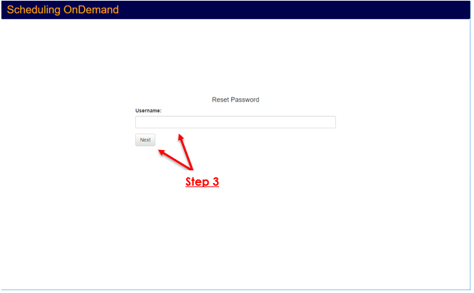

1. Answer the account security question and click continue

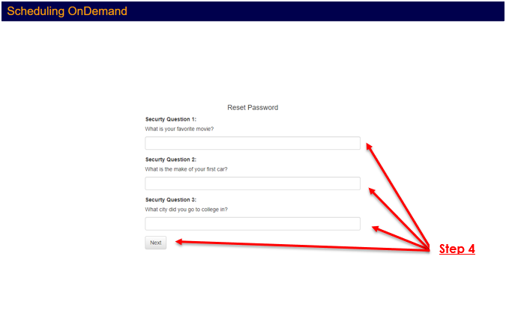

1. Enter a new password and click on confirm

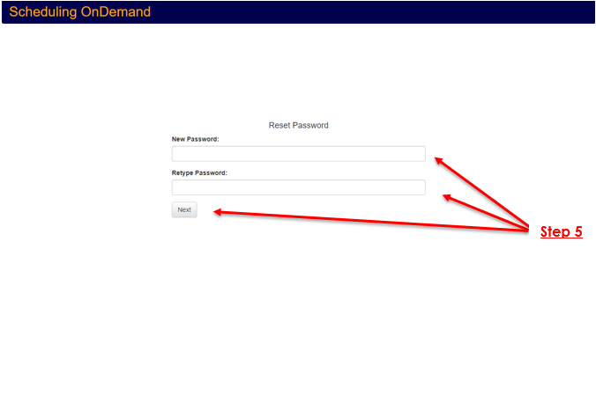

1. On the password rest confirmation page click on Login to get redirected to the login page then enter the username and the newly created password in the dedicated fields and click Log In

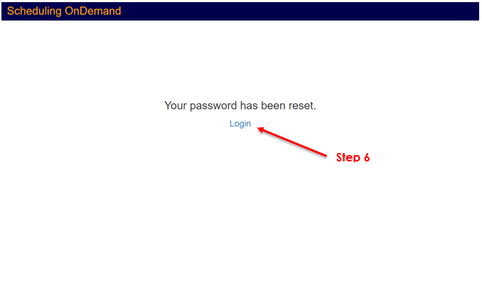

## Manager Main Dashboard

1. Navigation Bar Buttons:
   1. Dashboard
   2. Manage Shifts
   3. Manage Users
   4. About
   5. Profile
   6. Log Out
2. Refresh Button
3. Dashboard List
   1. Requested Shifts
   2. Uncovered Shifts < 5 Days - (within 5 days of the shift start date)
   3. Uncovered Shifts (Last 30 Days) – (all shifts that went uncovered in the last 30 days)
4. Shift Detail Links

*\*Diagram on next page\**

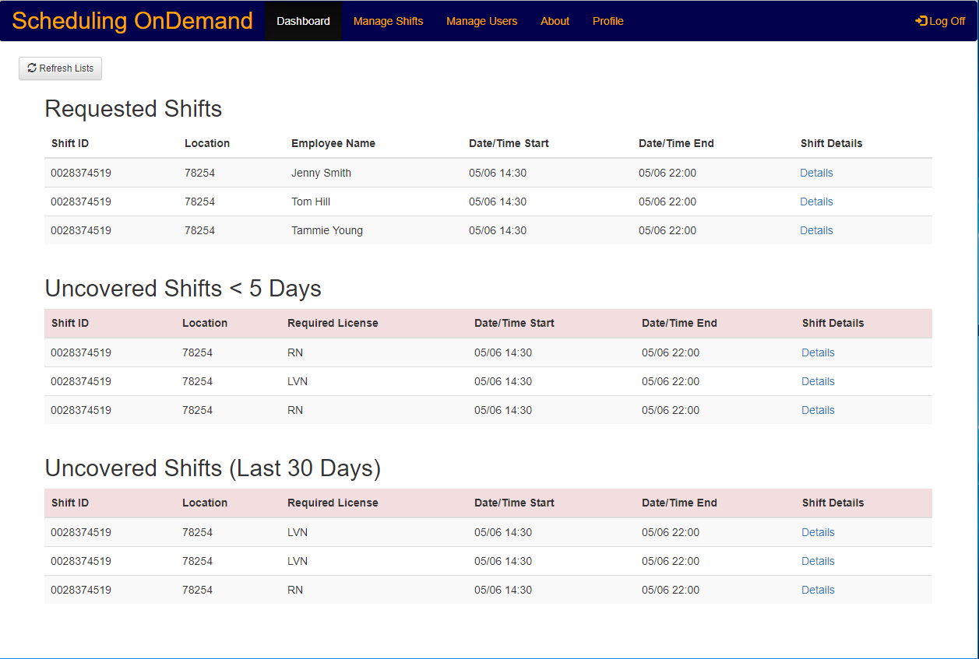

**4**

**3.c**

**3.b**

**3.a**

**2**

**1.f**

**1.e**

**1.d**

**1.c**

**1.b**

**1.a**

## Managing Users

### Create A User

1. From the Manager Dashboard click on Manage Users.

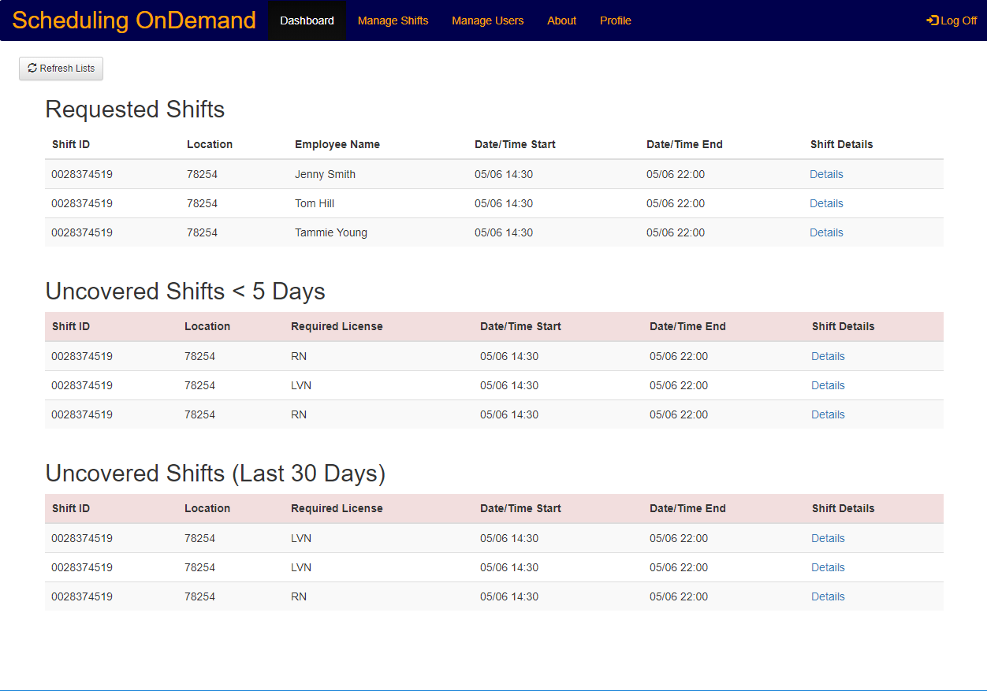

**1**

1. Once on the Manage Users dashboard click on the Create User button

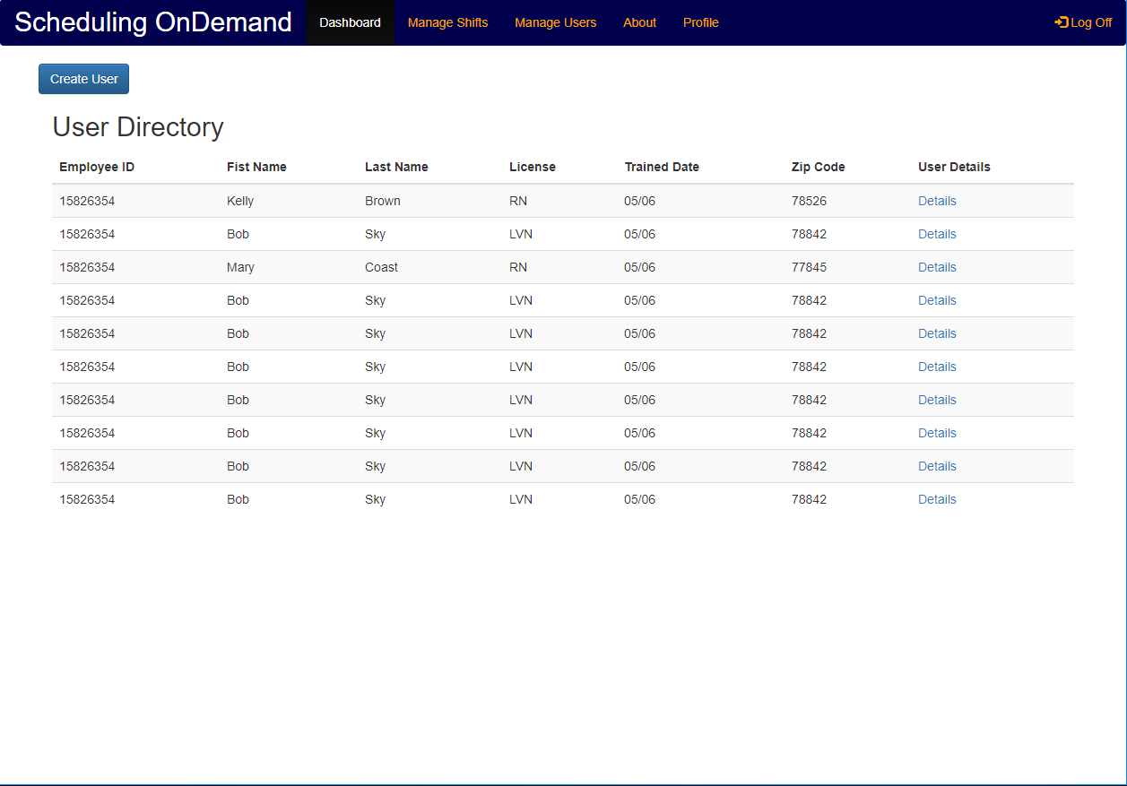

**2**

1. Fill in all the required fields with the appropriate information

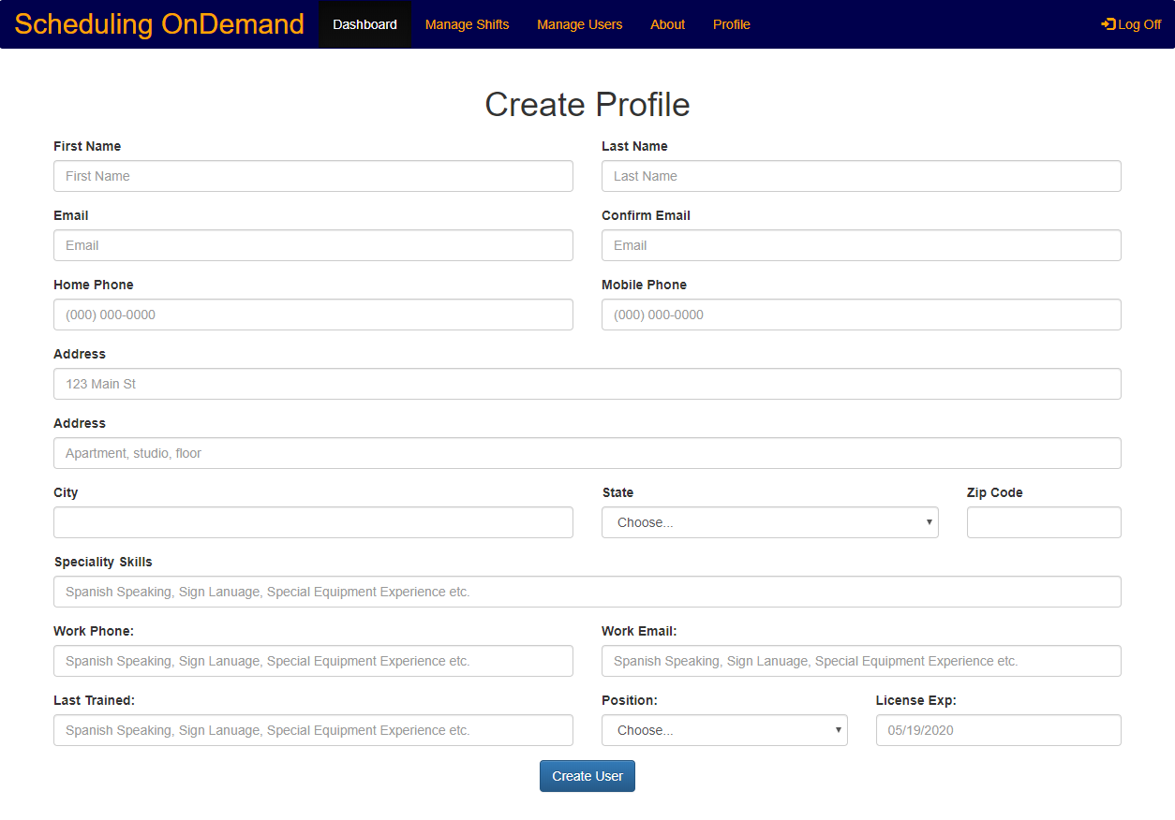

**3**

**4**

1. Click on the Create User button

### Modify A User

1. From the Manager Dashboard click on Manage Users



**2**

**1**

1. Once on the Manage Users dashboard click the user details link



**2**

1. On the User Details screen click on the Edit User button

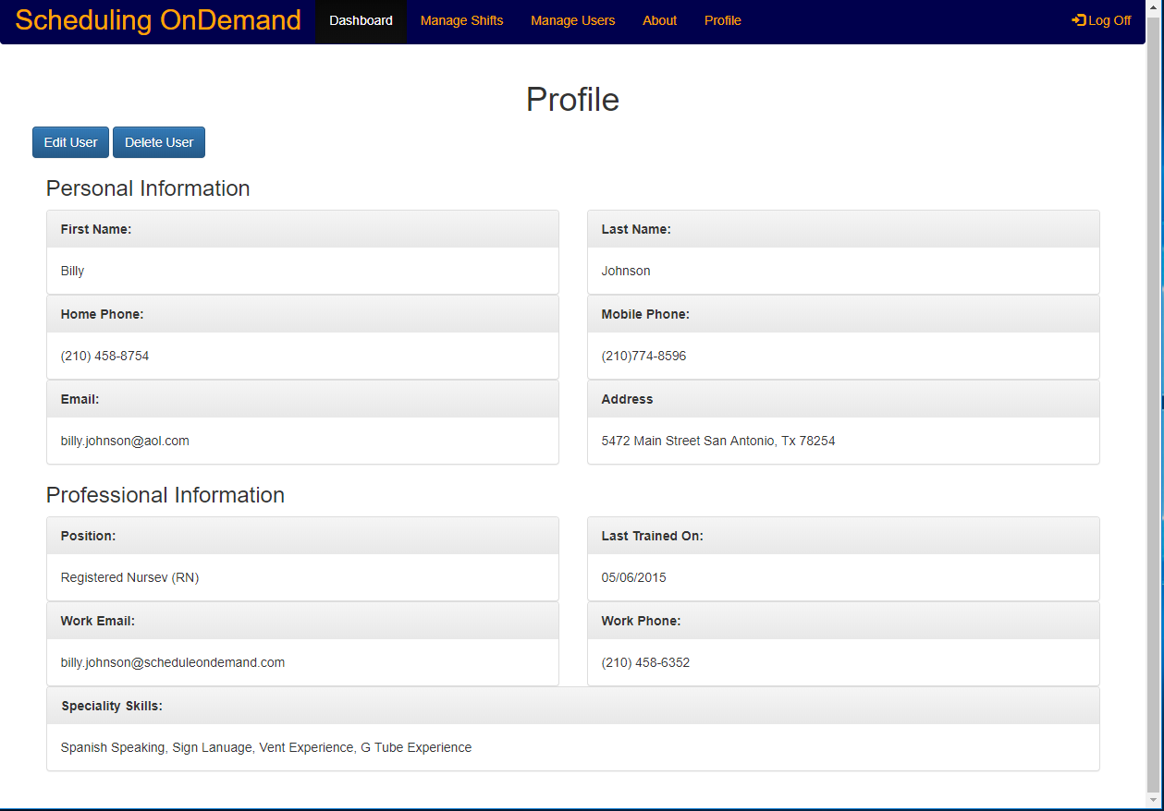

**3**

1. Once on the Modify User page change the User’s information as needed

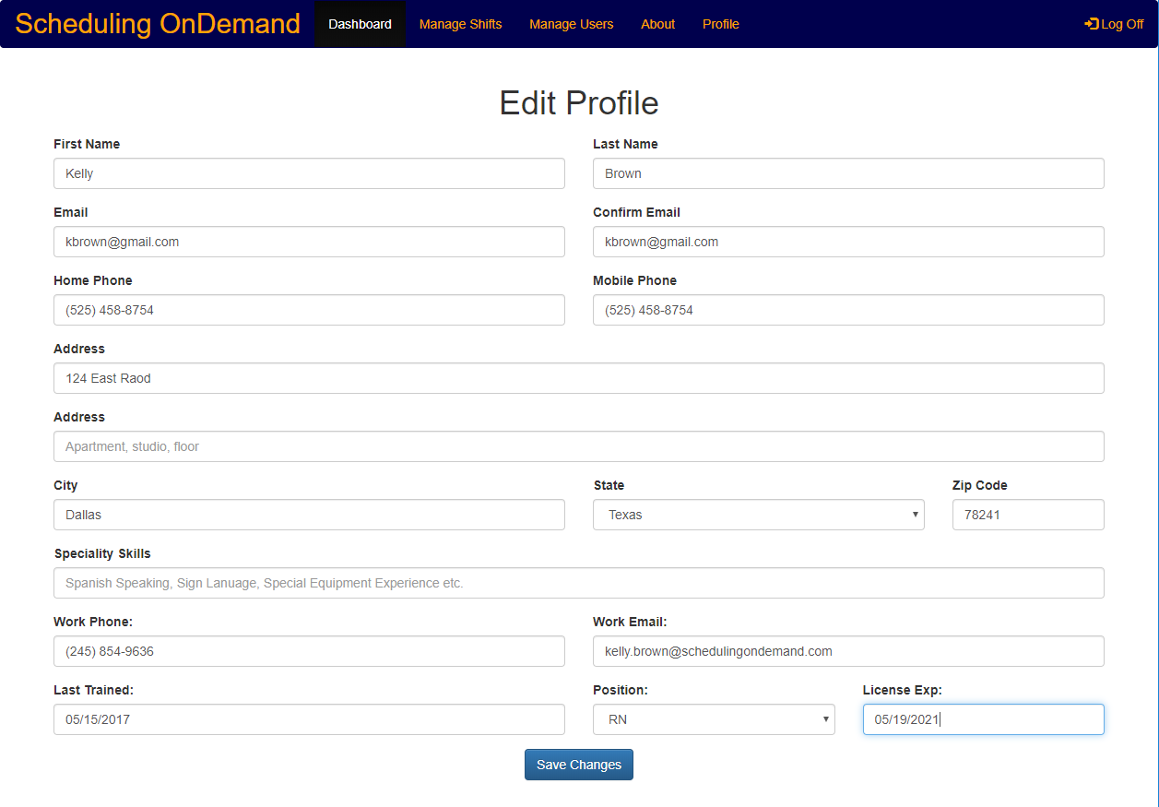

**5**

**4**

1. Click on Save Changes to save any changes made to the user

### Delete A User

1. From the Manager Dashboard click on Manage Users



**3**

1. Once on the Manage Users Dashboard click the user you wish to modify

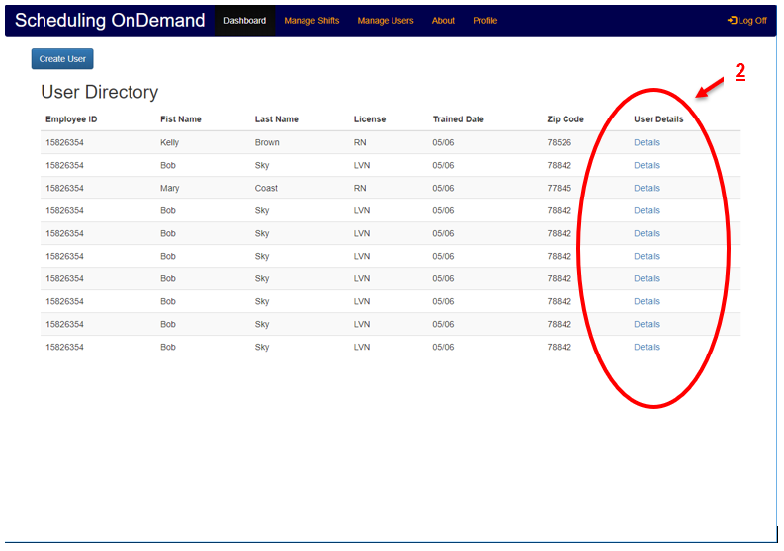

1. On the User Details screen click on the Delete User button



**5**

1. At the confirmation page you can use the return to user directory link to return to the user directory.

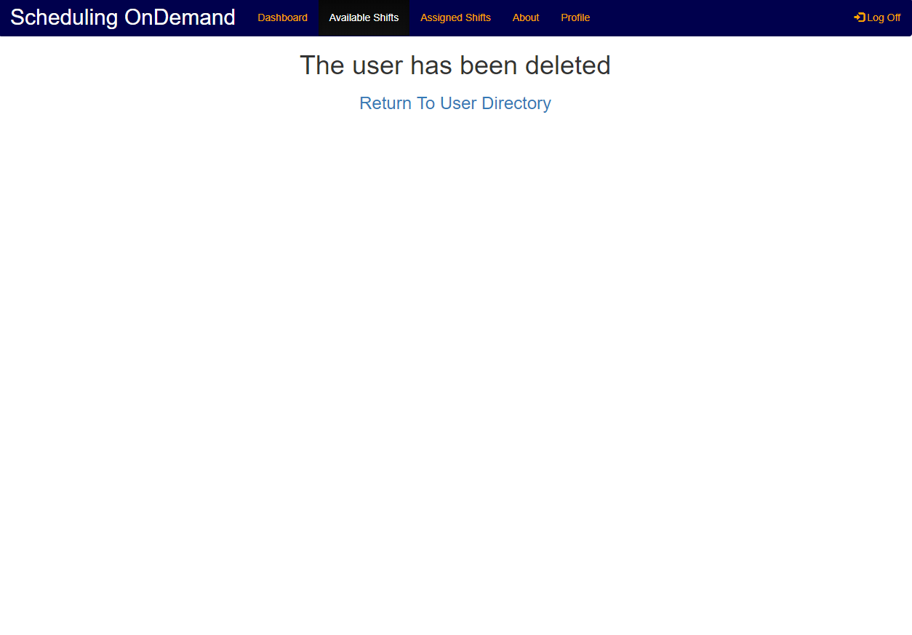

## Managing Shifts

### Create Available Shift

1. From the Manager Dashboard click on Manage Shifts
2. Once on the Manage Shifts Dashboard click the Create Shift button
3. Enter the required information in the appropriate fields
4. Click the Create Shift button

### Modify Available Shift

1. From the Manager Dashboard click on the Manage Shifts
2. Once on the Manage Shifts Dashboard click the shift you would like to modify
3. On the Shift Details screen click the Modify Shift button
4. Edit the shift’s details as needed
5. Click the Save Changes button to save the changed information to the shift

### Delete Available Shift

1. From the Manager Dashboard click on Manage Shifts
2. Once on the Manage Shifts Dashboard click the shift you would like to modify
3. On the Shift Details screen click on the Delete Shift button
4. Confirm the action to delete the shift

### Assign Employee to Shift

1. From the Manager Dashboard click on Manage Shifts
2. Once on the Manage Shifts Dashboard click the shift you would like to add an Employee to
3. On the Shift Details screen click the Assign Employee button
4. Select the Employee from the list of Employees and click “Assign”

### Unassign Employee from Shift

1. From the Manager Dashboard click on Manage Shifts
2. Once on the Manage Shifts Dashboard click the shift you would like to add an Employee to
3. On the Shift Details screen click the Unassign Employee button

## Managing User Shift Requests

### Approve A Shift Request

1. From the Manager Dashboard click on the Manage Requests
2. Once on the Manage Request page check the box of the shift you wish to approve
3. Click on the Approve button to approve the checked shift

### Deny A Shift Request

1. From the Manager Dashboard click on the manage requests
2. Once on the manage request page check the box of the shift you wish to deny
3. Click on the Deny button to disapprove the checked shift

# Troubleshooting

## Scheduling OnDemand Support

### Email Customer Support:

Email us at [support@schedulingondemand.com](mailto:support@schedulingondemand.com) if you have any questions. Please be advised all help desk tickets submitted to [support@schedulingondemand.com](mailto:support@schedulingondemand.com) will be answered in the order they are received and Monday – Friday from 8AM – 5PM.

### Contact Customer Support:

For assistance please contact us at 1800-000-0000. Please be advised that all calls to Scheduling OnDemand at 1-800-000-0000 will be answered 24/7 in the order they are received.

# FAQs

1. **Q: Can Scheduling OnDemand support team elevate my account to a management account?**

**A:** No. Your account can’t be elevated to a management account by a Scheduling OnDemand support staff. In order to get your account elevated you will need to contact your admin (management) and request the account elevation through them. Scheduling OnDemand does not make account modifications for users.

1. **Q: Can Scheduling OnDemand unlock my account if I can not unlock it using the “Forgot My Password” link due some reason?**

**A:** No. If you can not unlock your account on your own for some reason (forgot email, failed security question, or any other reason) you will need to contact your admin (management) in order to have your account unlocked. Scheduling OnDemand only support recovery of forgotten passwords to admin accounts.

1. **Q: Is there a way to assign and cancel shifts that have either been assigned to me or that I have signed up for?**

**A:** No. All schedule assigning/ canceling needs to be approved/disapproved by an admin in order to ensure that admins are aware of all changes.

1. **Q: Can I change my personal information like address and phone number associated with my Scheduling OnDemand account?**

**A:** Yes. In order to change your personal information please click on profile then select account settings from the drop-down list. This will take you to your personal account which also allows you to change specific information like addresses, phone numbers, and email addresses.

1. **Q: I no longer want to have an account can I delete my account?**

**A:** Yes. In order to change your personal information please click on profile then select account settings from the drop-down list. This will take you to your personal account which will allow you to delete your Scheduling OnDemand account. *\*\*WARNING** KEEP IN MIND IF YOU DELETE YOUR ACCOUNT YOU WILL HAVE TO CONTACT YOUR ADMIN TO HAVE A NEW ACCOUNT CREATED.*

1. **Q: Can Scheduling OnDemand make account modifications for manager accounts?**

**A:** Yes. Scheduling OnDemand can make limited modifications to manager accounts.

1. **Q: Can an manager account be changed to a user account?**

**A:** Yes. A manager account can be changed, however, will need to be done by Scheduling OnDemand in order to prevent unauthorized de-elevating of management accounts.

1. **Q: Can a shift be deleted once a user has been assigned to it?**

**A:** Yes. A shift with a user assigned to it is deleted in the same way that a shift with no user assigned to it is deleted. To delete a shift from the admin dashboard you would click on manage schedules. Once on the manage schedule page you will check the box next to the schedule you want to delete then click on delete shift.

1. **Q: Can a manager create a user account?**

**A:** Yes. From the Manager Dashboard you will click on “Manage Users” then click on “Create User” from within the Manage User Dashboard.

1. **Q: Can a manager account elevate a user account to an admin account?**

**A:** Yes. In order to elevate a user account to a manager account you must first login as a manager. Once logged in as a manager click on manage users then locate the user that is going to be elevated to a manager. Check the box associated with the that user and click modify user. Once the modify user page comes up toggle the Role from Employee to Manager and click Confirm/Submit.